UNIVERSIDAD DE LAS AMERICAS PUEBLA

PROJECT 2

GAN TO GENERATE FACES

DR. INGRID KIRSCHNING ALBERS

ANGEL DAVID MORENO LOZANO

INTELIGENCIA ARTIFICIAL

02/ABRIL/2023

Generative Adversarial Networks (GANs) are important because they provide a powerful framework for generating synthetic data, particularly images, that are difficult to distinguish from real data. This has important applications in many fields, including computer vision, graphics, and data augmentation for machine learning.

GANs can be used to generate new, realistic images of faces, landscapes, animals, and other objects. By training a generator network on a large dataset of real images, the generator can learn to produce new images that are similar in style and content to the training data. This has important applications in the fields of computer graphics and visual effects, where GANs can be used to generate realistic images of objects and scenes that are difficult or expensive to capture with traditional methods.

GANs also have important applications in the field of data augmentation for machine learning. By generating synthetic images that are similar to real images, GANs can be used to augment training datasets, which can improve the performance of machine learning models. For example, in object recognition tasks, GANs can be used to generate new images of objects from different angles or in different lighting conditions, which can improve the accuracy of object recognition models.

Furthermore, GANs have the potential to revolutionize many areas of computer vision and machine learning. They provide a powerful framework for generating synthetic data that can be used to train and test machine learning models, and they have already been shown to improve the performance of state-of-the-art models in many tasks. Additionally, GANs have the potential to enable new applications in fields such as robotics, autonomous vehicles, and virtual reality, where realistic and diverse visual data is critical for success.

Overall, GANs are important because they provide a powerful framework for generating synthetic data that is difficult to distinguish from real data. They have important applications in many fields, including computer vision, graphics, and machine learning, and have the potential to revolutionize many areas of technology and society. As research into GANs continues, we can expect to see many exciting new developments and applications of this powerful technology.

GANs have gained significant attention from the machine learning community since their introduction in 2014 by Ian Goodfellow and his colleagues. GANs are a type of deep neural network architecture that can generate synthetic data, such as realistic images of faces, by training two neural networks in a game-theoretic setting. The generator network takes random noise as input and produces fake images, while the discriminator network tries to distinguish between fake and real images from a training dataset.

The generator network tries to improve its performance based on the discriminator's feedback, while the discriminator tries to improve its performance based on the generator's output. This process is repeated until the generator generates realistic images that are difficult for the discriminator to distinguish from real images. In the context of generating faces, the generator takes random noise as input and generates an image that looks like a human face, while the discriminator is trained to distinguish between real and synthetic faces.

To train GANs to generate realistic faces, large amounts of training data are required. The CelebA dataset, which contains over 200,000 celebrity face images, has been widely used in GAN research. Various improvements to the basic GAN architecture have been proposed, such as DCGAN, WGAN, and StyleGAN, which have shown to produce high-quality and diverse images of faces.

GANs are still an active area of research, and there are many challenges and open questions in the field. For instance, improving stability and convergence during training, controlling the generation process, and understanding the underlying principles that govern GANs. However, GANs have already shown great promise in generating realistic and diverse images, and they have the potential to revolutionize many areas of computer vision and image synthesis.

In conclusion, GANs have shown impressive results in generating realistic faces and other types of images. GANs have also been used for a wide range of applications beyond image generation. With ongoing research, GANs have the potential to advance the field of machine learning and open up new possibilities for generating synthetic data.

**Ejemplo 50epox 128x128 3171img**



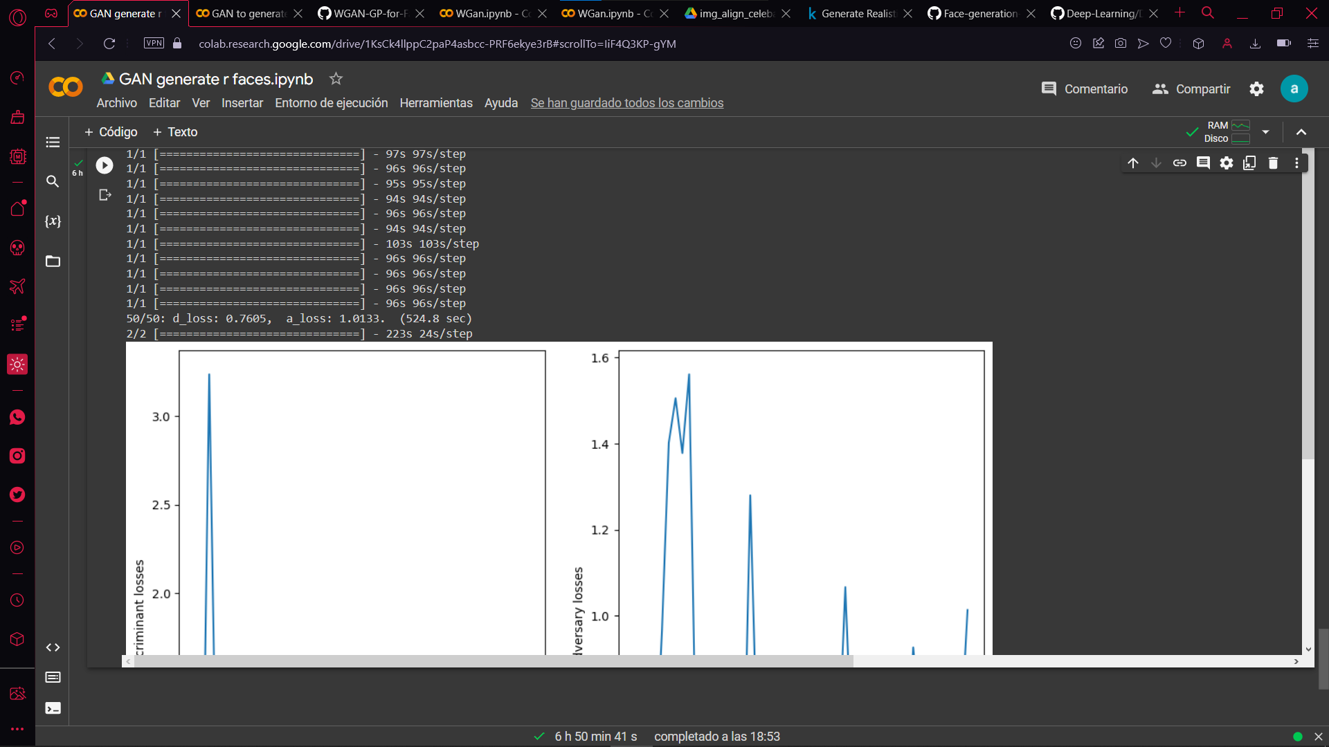

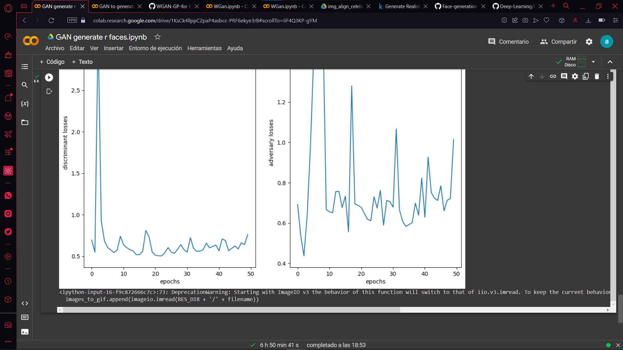

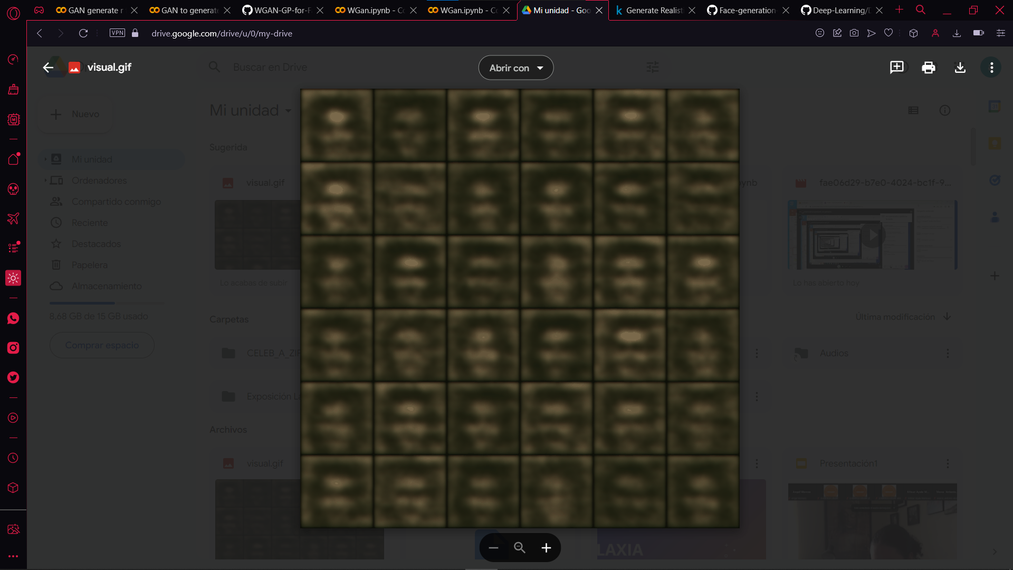

**Ejemplo con 20mil img 50epox 64x64**

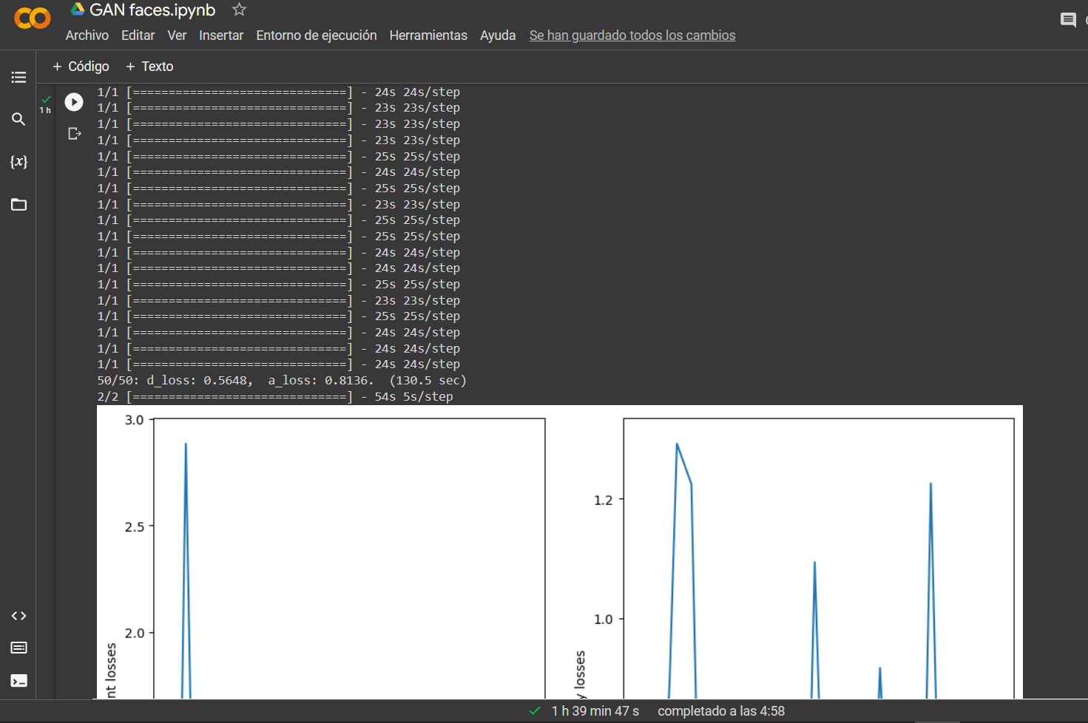

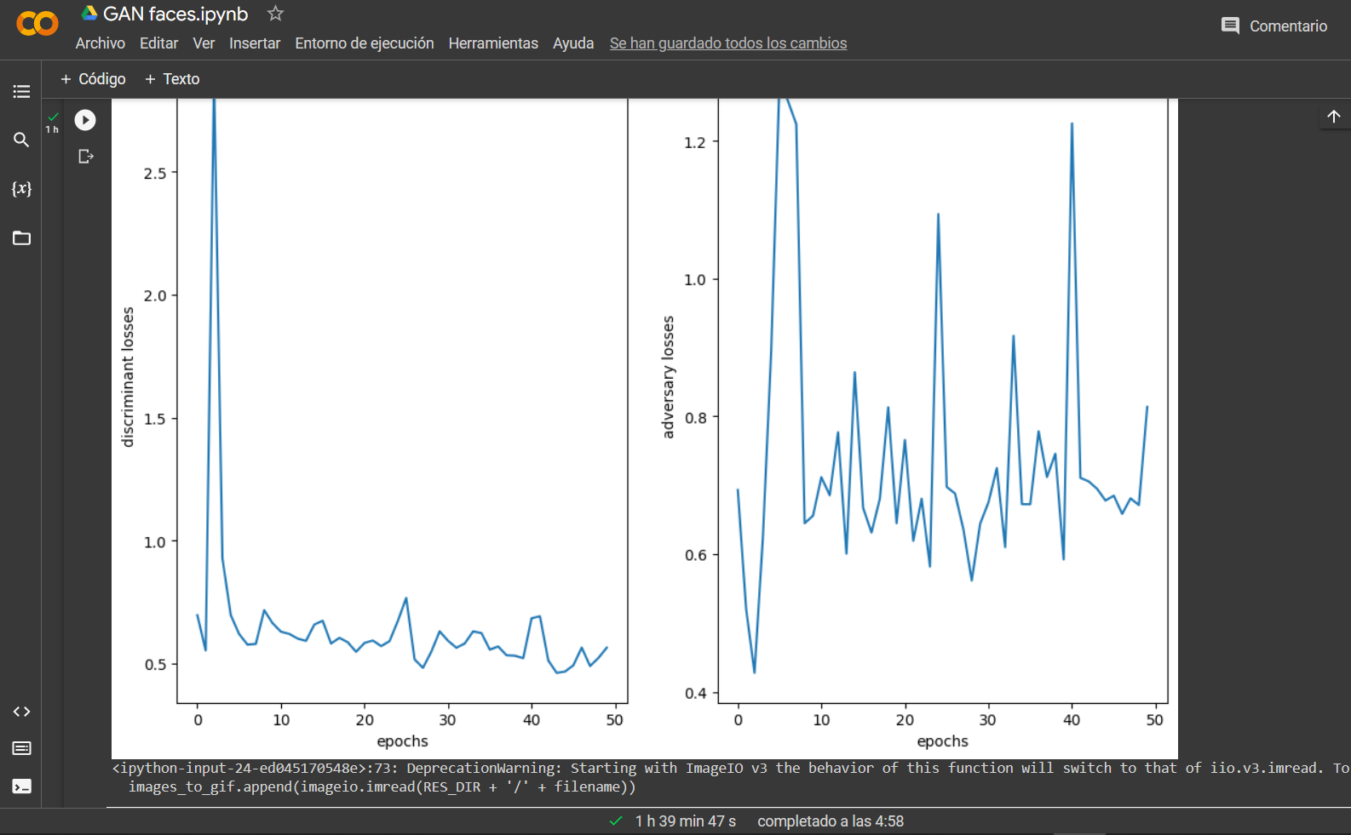

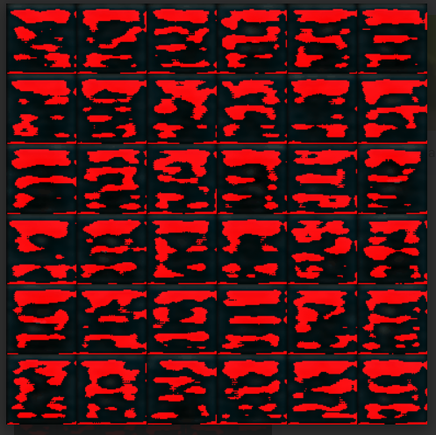

Ejemplo 100epox 64x64 10232img

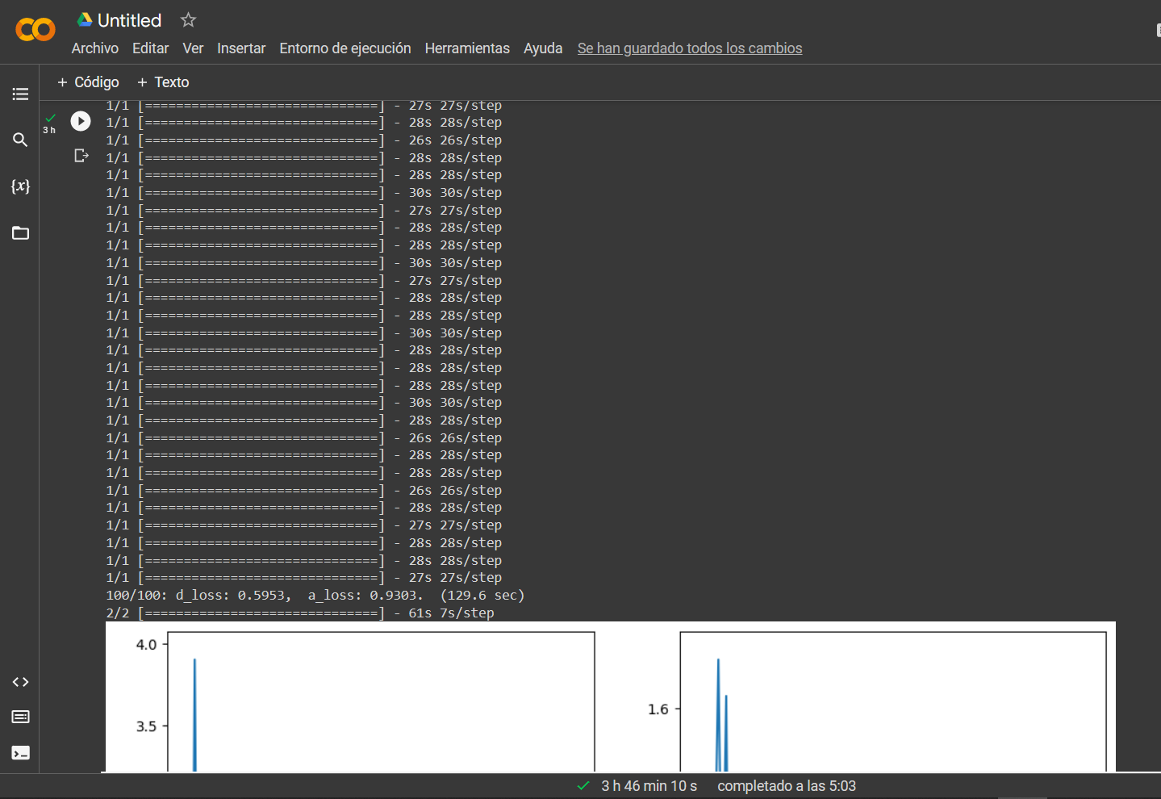

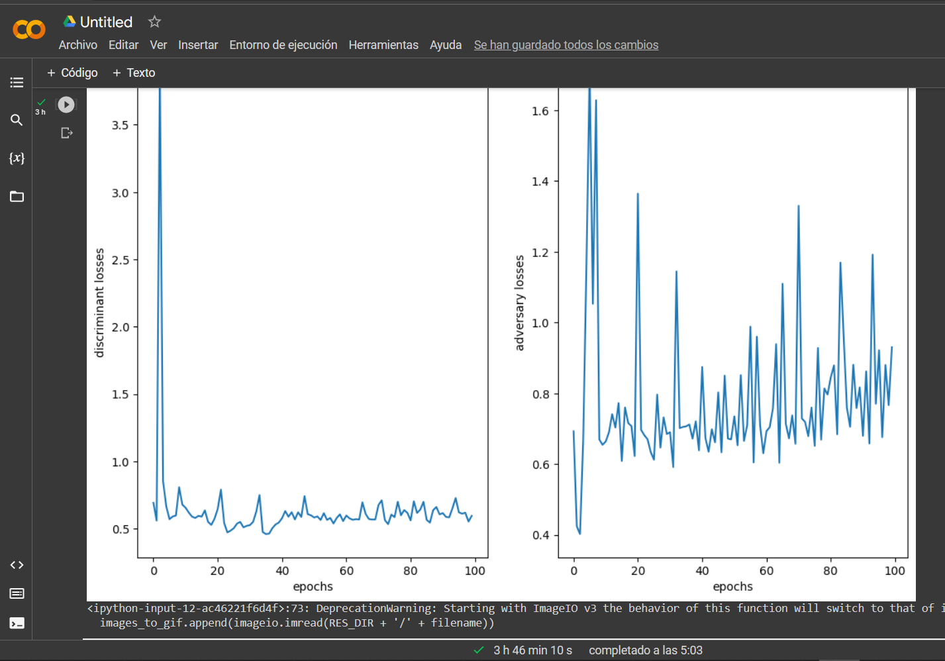

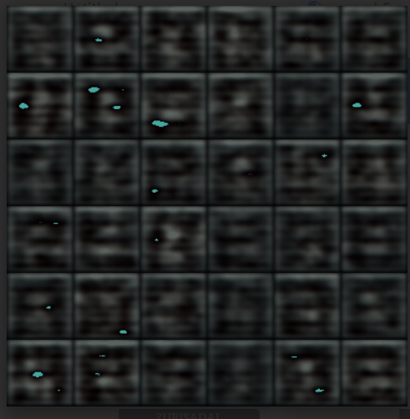

**Ejemplo 128x128 3171img 80epox**



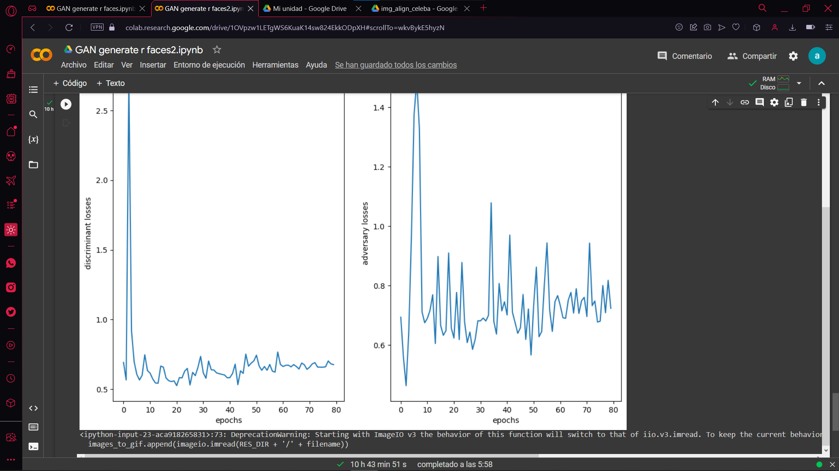

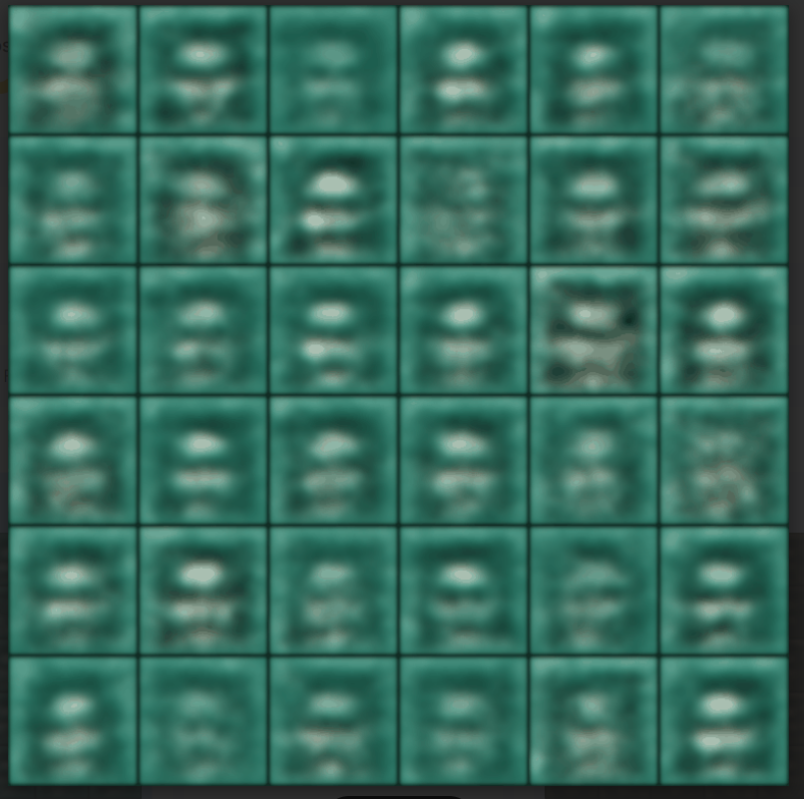



**Ejemplo 200epox 64x64 10232img**

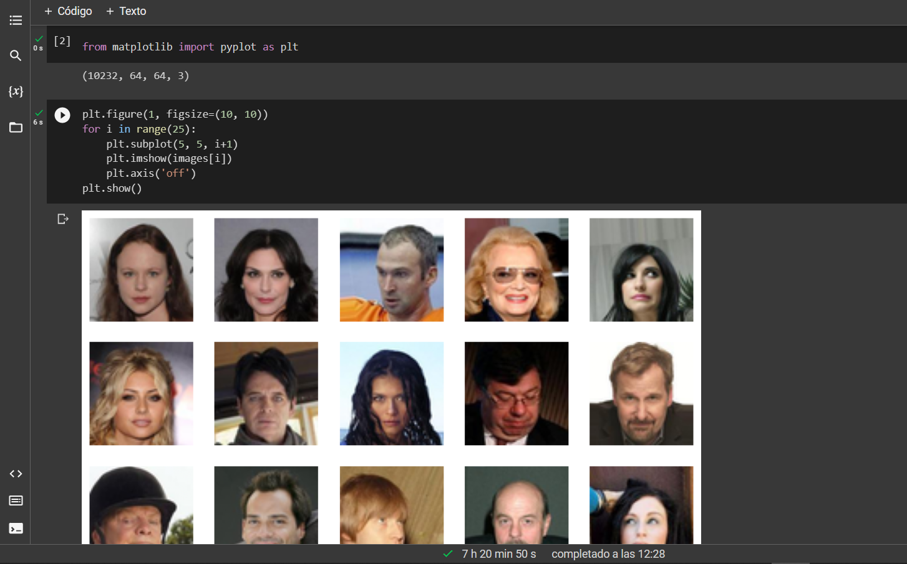

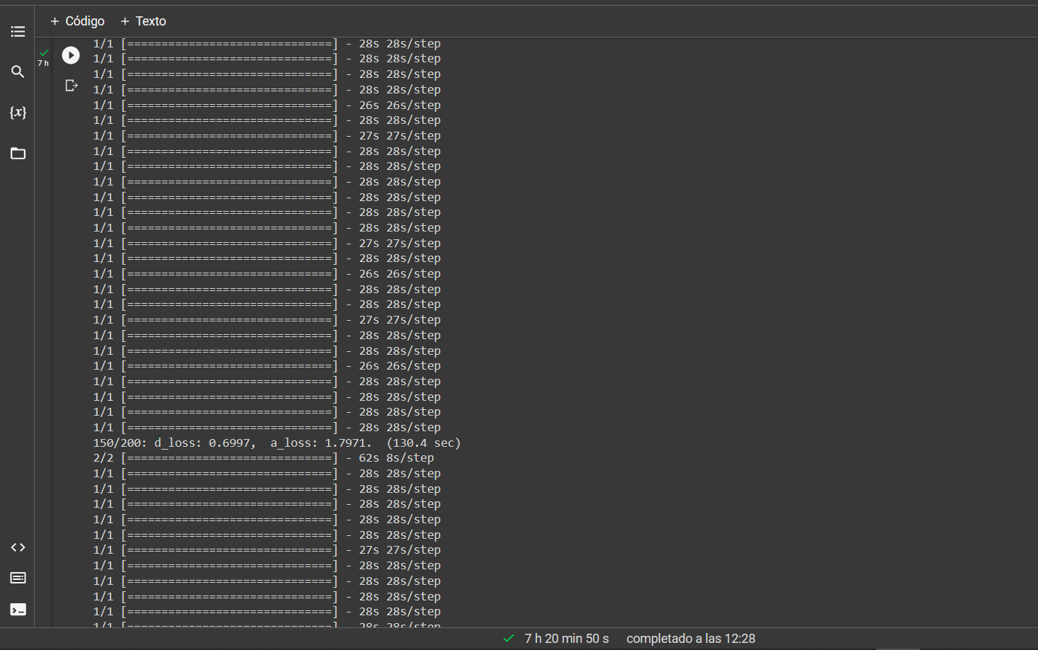

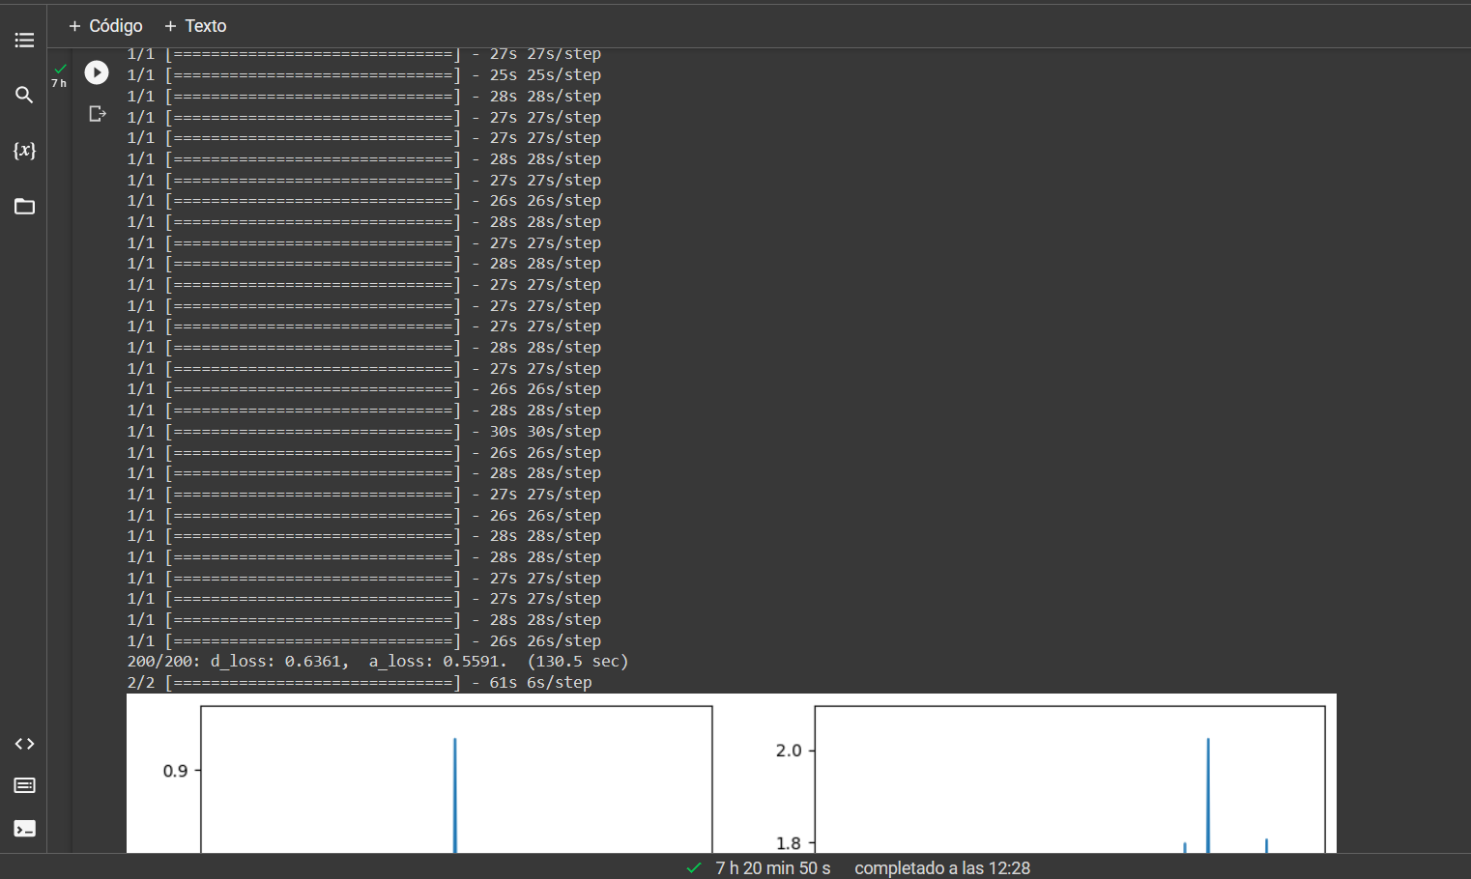

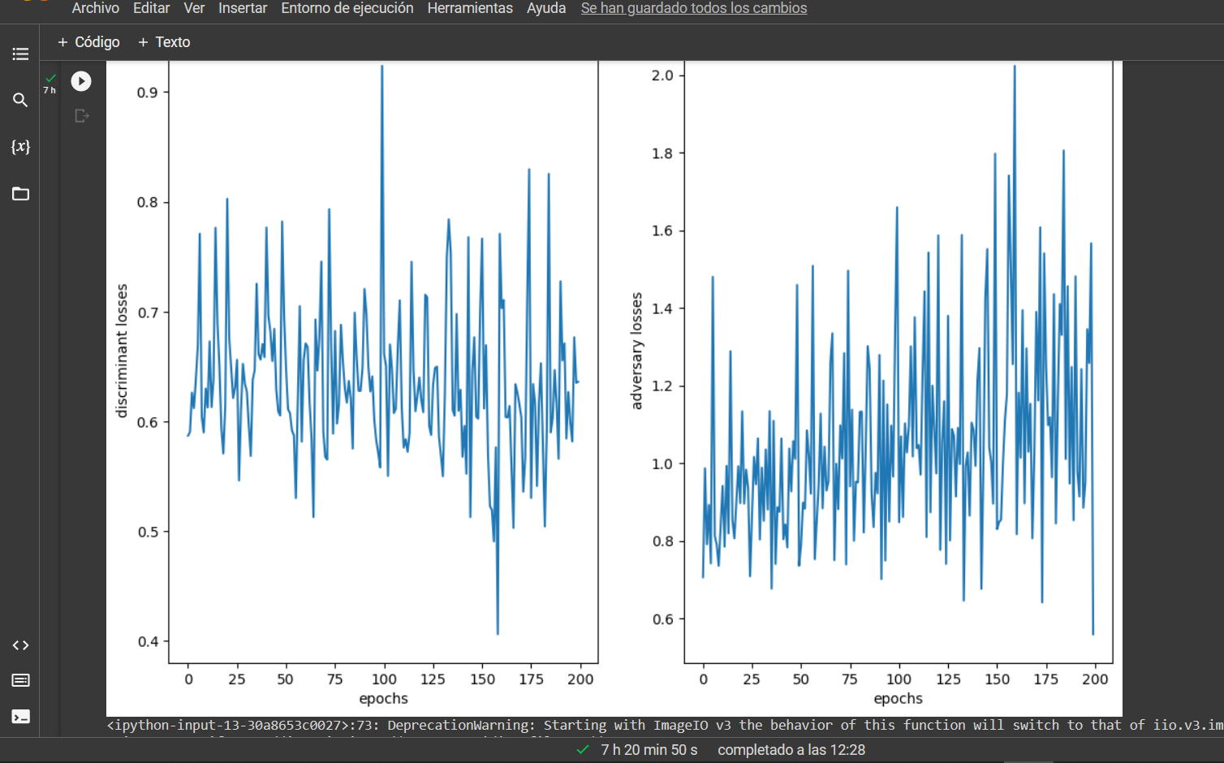

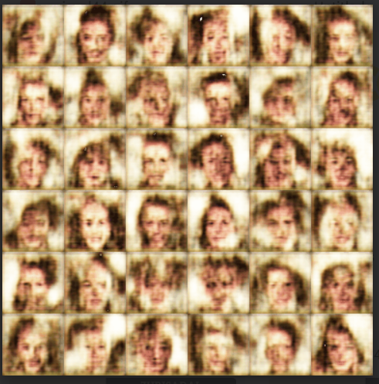

**Ejemplo 8200img 128x128 500epox**

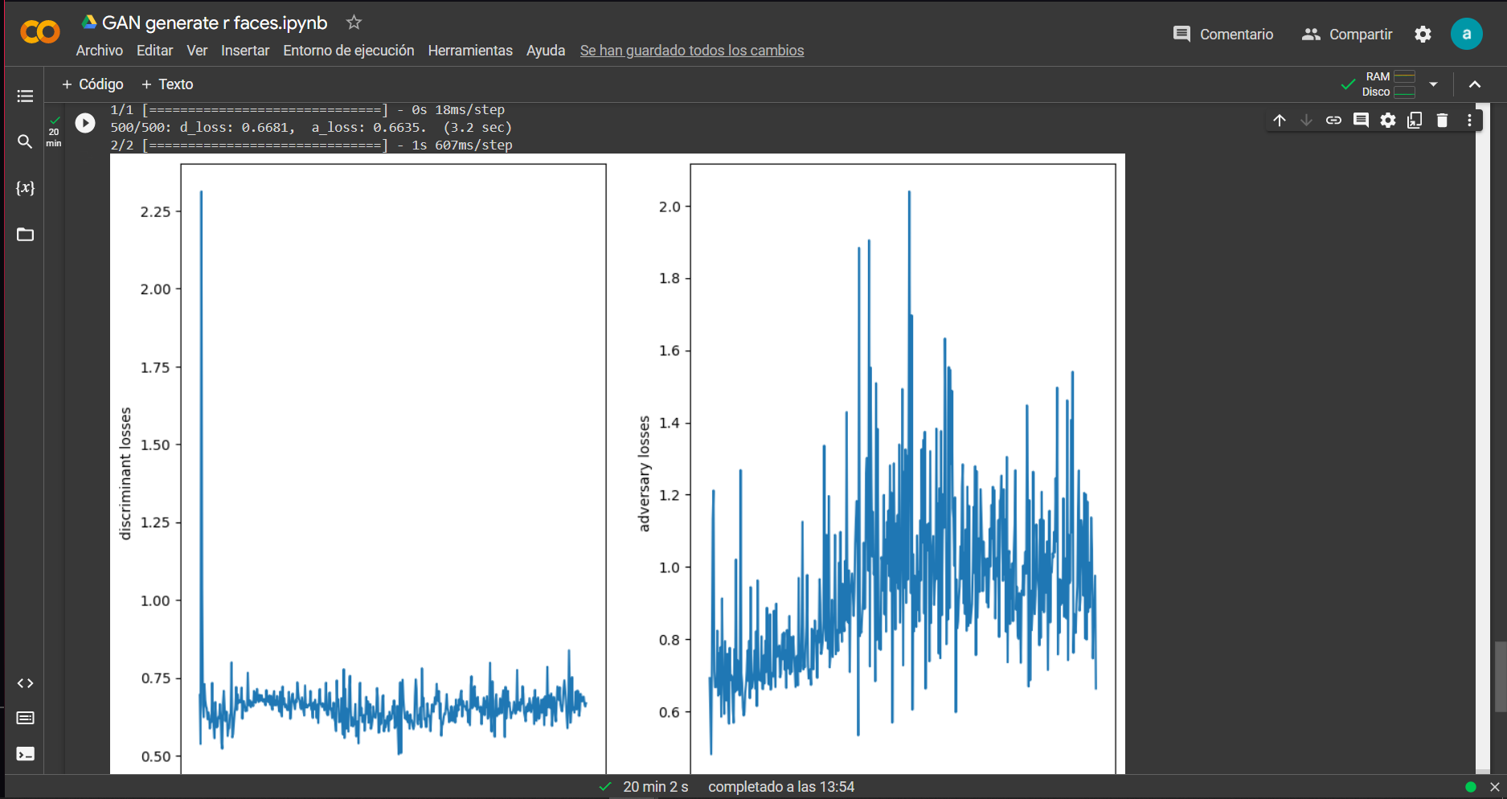

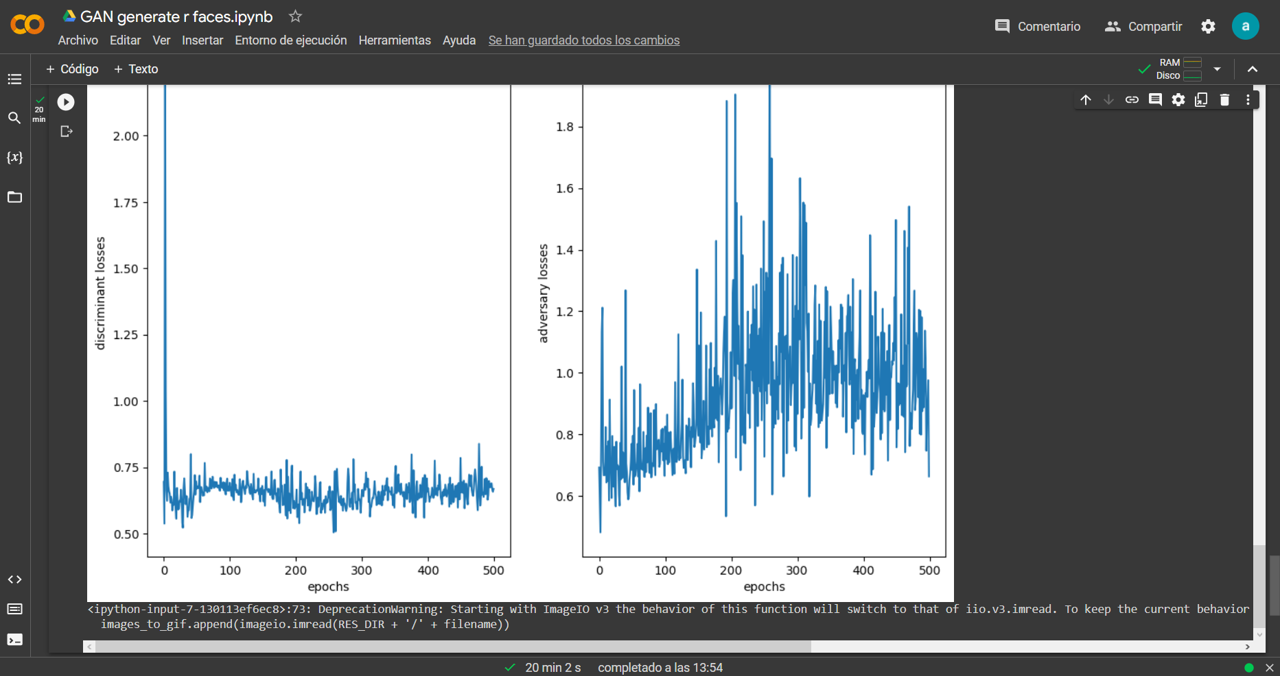

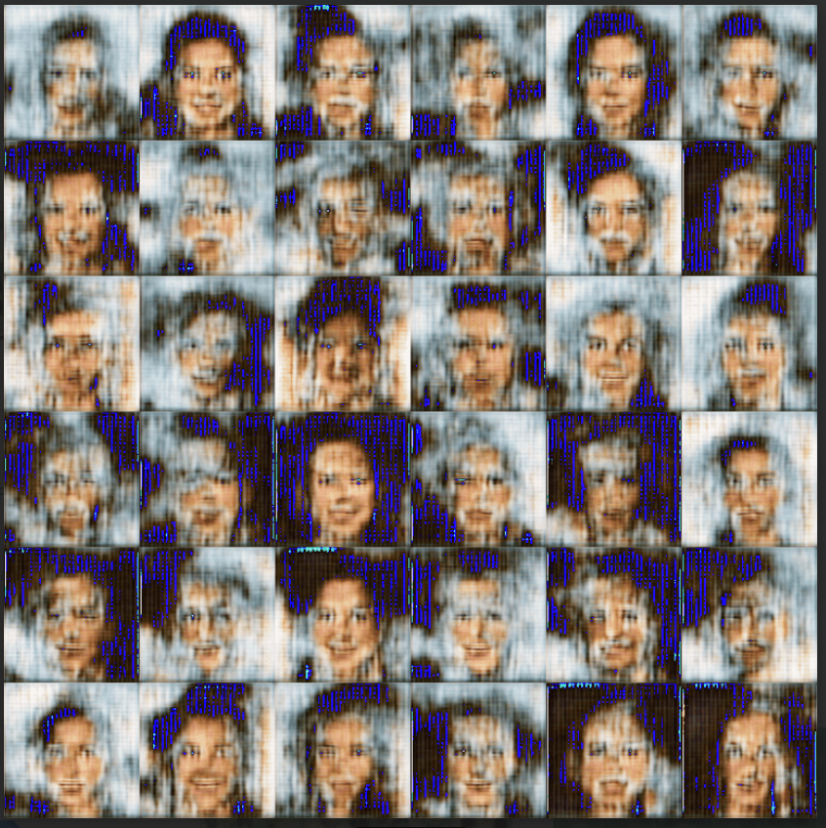

**Ejemplo 12mil img 128x128 500epox**

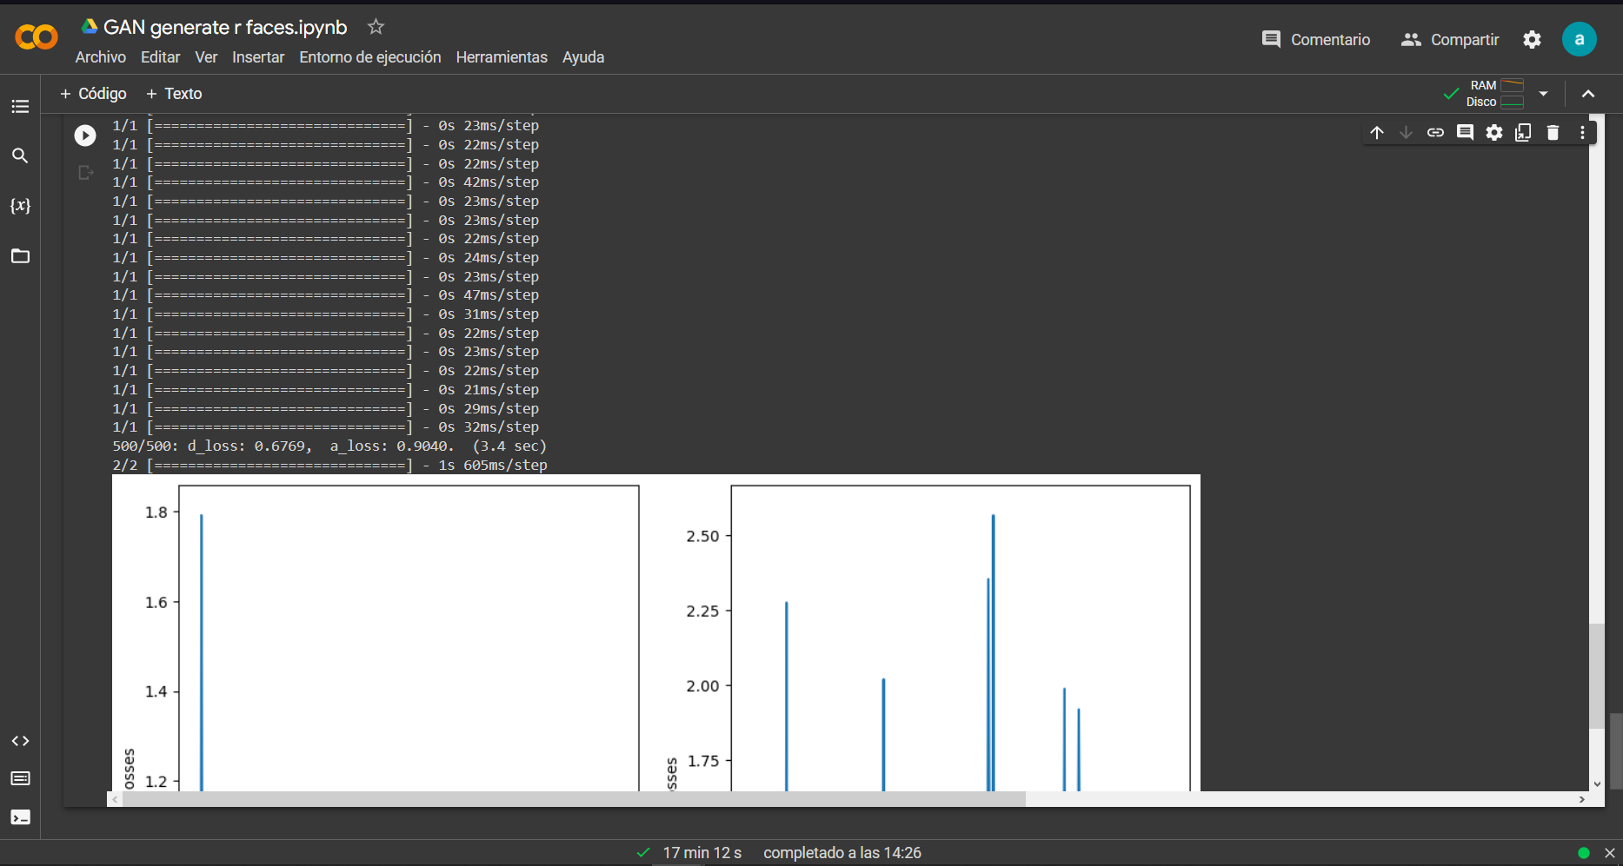

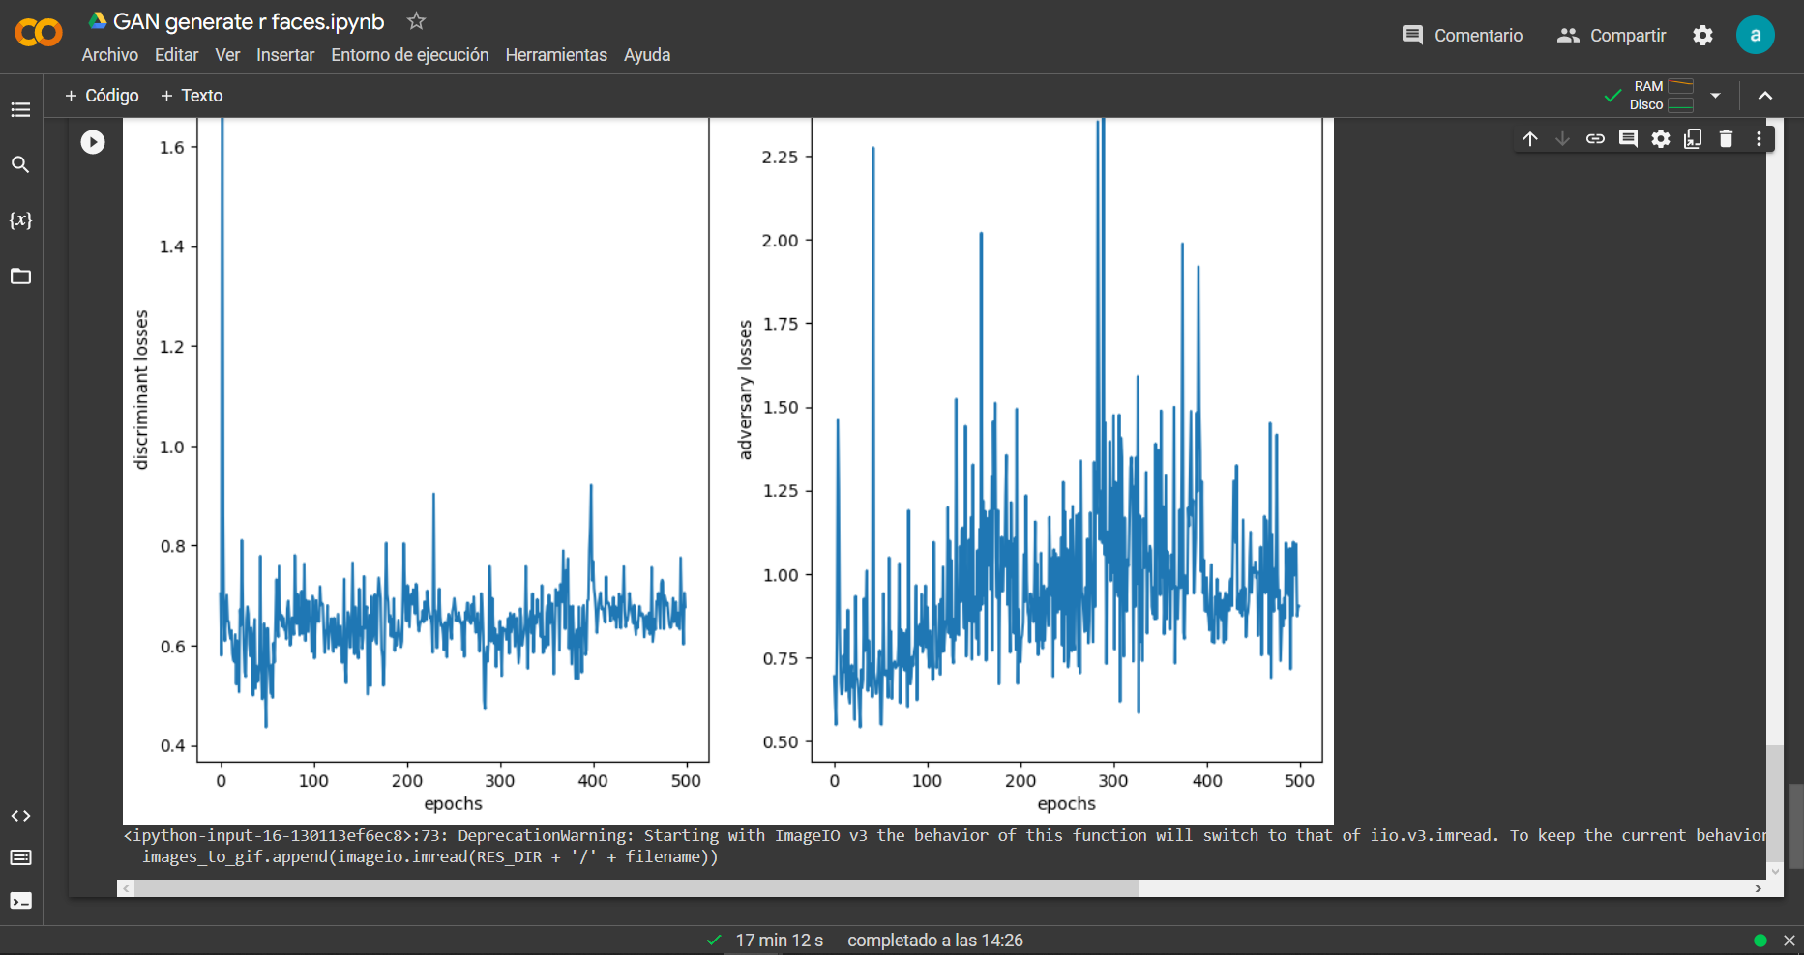

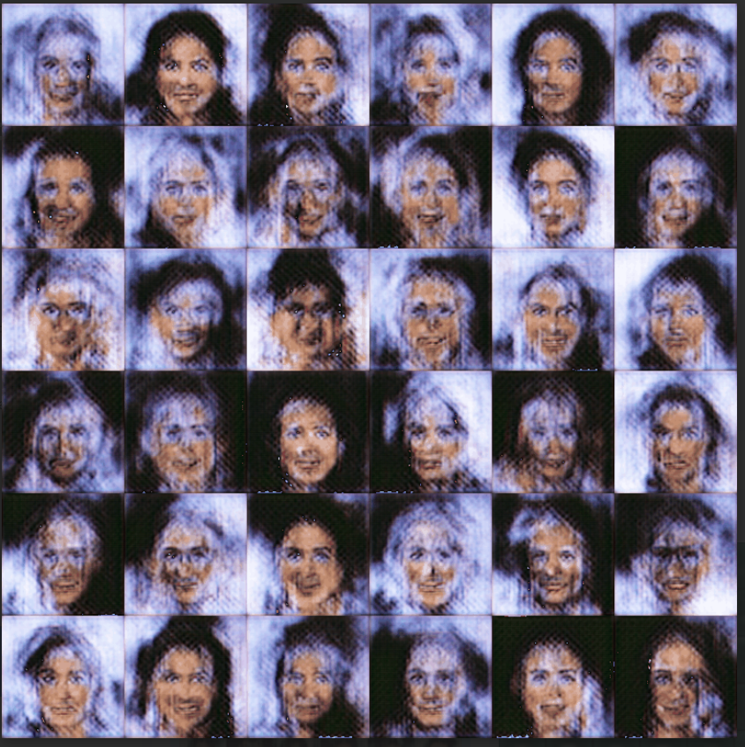

**Ejemplo 7mil img 64x64 350epox**

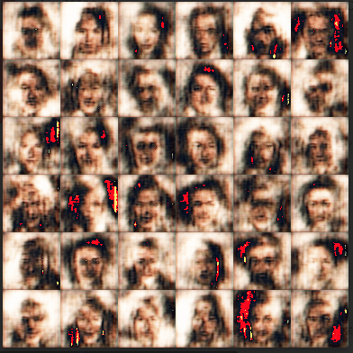

**Ejemplo 7mil img 350epox 64x64 con modificación en learning rate a 0.000001**

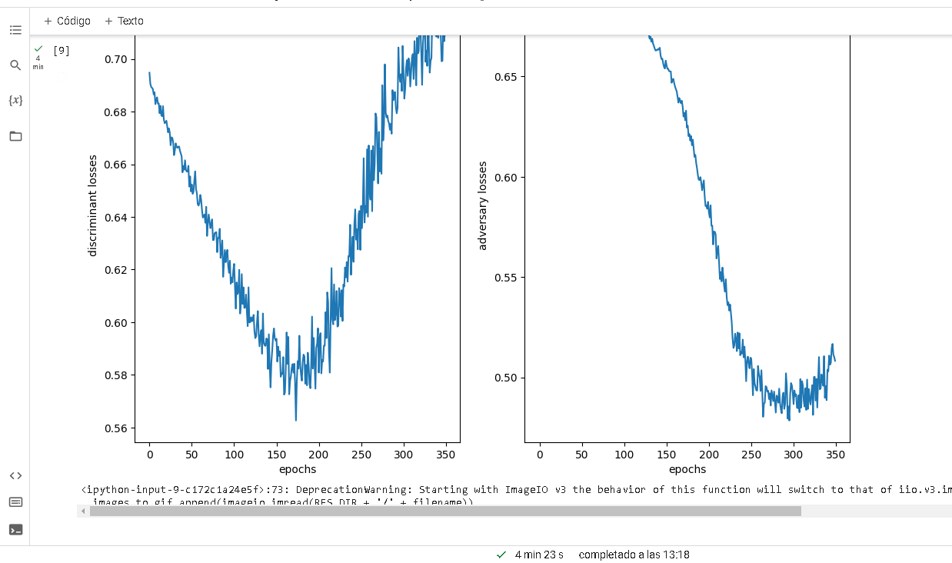

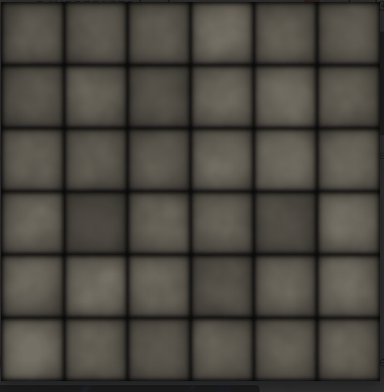

**Ejemplo 64x64 1350epox 7mil img learning rate 0.0001**

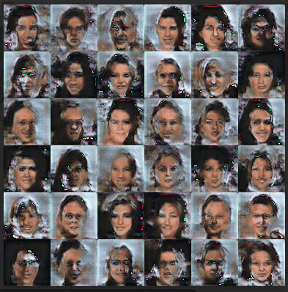

References:

Goodfellow, Ian, et al. "Generative adversarial nets." Advances in neural information processing systems. 2014.

Radford, Alec, et al. "Unsupervised representation learning with deep convolutional generative adversarial networks." arXiv preprint arXiv:1511.06434 (2015).

Zhang, Han, et al. "Self-attention generative adversarial networks." International Conference on Machine Learning. PMLR, 2019.

Karras, Tero, et al. "A style-based generator architecture for generative adversarial networks." Proceedings of the IEEE Conference on Computer Vision and Pattern Recognition. 2019.